**Clarifier Window**

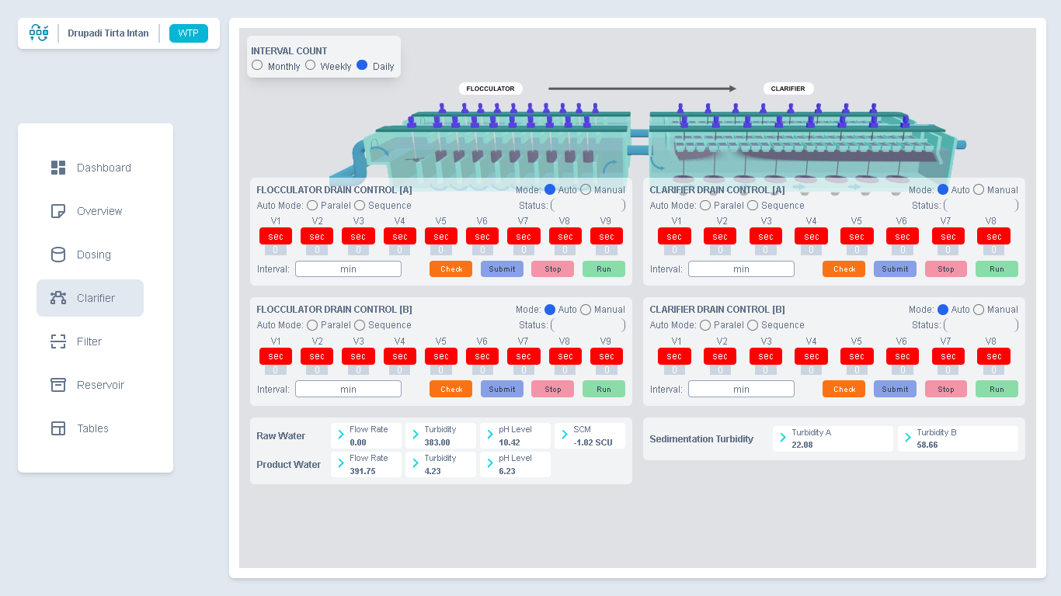

1. **Implementation of Relay Workflow**
2. **Control of Flocculation**
3. **Mode Manual**
4. **Mode Auto**
5. **Control of Sedimentation**
   1. **Mode Manual**
   2. **Mode Auto**

